Math 1 Name ______________________________
6-4 Triangle Properties Practice 2 Date________

Solve for Angle A in the following.

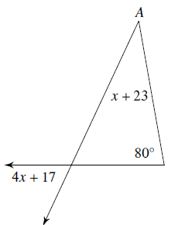

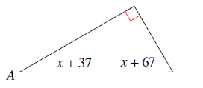

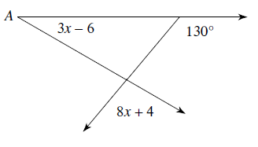

Solve for x or the question mark in the following.

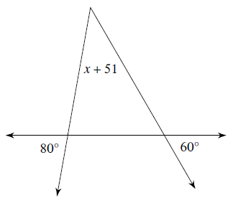

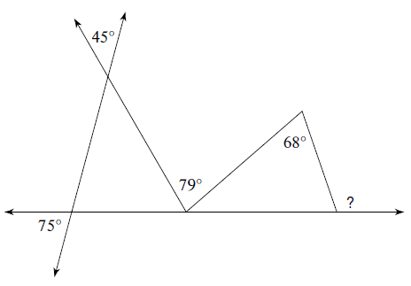

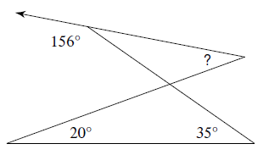

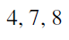
State if the three numbers can be the measures of the side of a triangle.

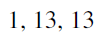

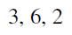

Two sides of a triangle have the following measures. Find the range of possible measures for the third side.
